Toolbox Talk Template:

Title:
Toolbox Talk: Display Screen Equipment (DSE) Assessments

Introduction:
Presenter Name and Role:

Purpose of Today’s Toolbox Talk:
In today’s 10 minute session, we’ll cover:
- What DSE is and who qualifies as a DSE user
- What should be included in a DSE assessment
- Health risks and control measures for safe DSE use

Key Content:
- What is Display Screen Equipment (DSE)?
DSE includes:
• Computers
• Laptops
• Tablets
• Smartphones
• Other display screen-based devices used for prolonged periods at work
If you use DSE daily, continuously for an hour or more, you are considered a DSE user under the UK Health and Safety (Display Screen Equipment) Regulations 1992.

- What Should Be Covered in a DSE Assessment?
- Workstation Setup
  - Monitor height and distance
  - Keyboard and mouse placement
  - Desk space and layout
Chair ergonomics and adjustability
- Posture and Seating
  - Feet flat on the floor or on a footrest
  - Knees at a right angle
  - Back supported, especially lower back
- Screen Position
  - Top of the screen at or just below eye level
  - Arm’s length distance
  - Minimal glare or reflection
- Input Devices
  - Correct use and placement of the keyboard and mouse
  - Wrist rests and ergonomic accessories if needed
- Environment
  - Lighting and glare reduction
  - Noise levels
  - Temperature and air quality
- Breaks and Task Variation
  - Encouraging microbreaks
  - Eye breaks (20-20-20 rule: every 20 mins, look at something 20 feet away for 20 seconds)
  - Job rotation if possible
- Use of Laptops and Mobile Devices
  - Use of docking stations or external keyboards/mice for long-term use
  - Avoiding awkward postures when working on the move

How to set up your workstation
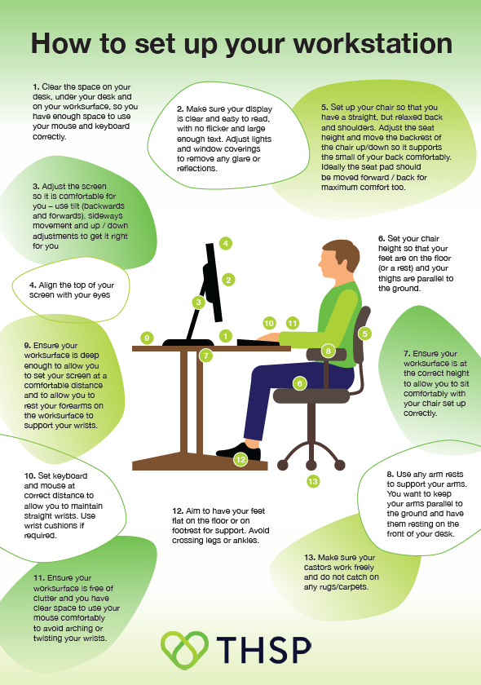

- Occupational Health Issues from Poor DSE Use
- Musculoskeletal Disorders (MSDs)
  - Neck, shoulder, and back pain
  - Repetitive strain injuries (RSIs)
  - Carpal tunnel syndrome
- Visual Fatigue
  - Eye strain
  - Blurred vision
  - Headaches
- Mental Health and Stress
  - Long hours of screen use with no breaks can contribute to fatigue and burnout
  - Poor posture and pain can also lead to decreased morale
- Sedentary Lifestyle
  - Long periods of sitting can increase the risk of obesity, cardiovascular disease, and diabetes

- Control Measures
  - Carry out regular DSE assessments (at least annually or when changes occur)
  - Provide training on proper workstation setup
  - Supply ergonomic equipment where needed
  - Encourage movement and regular breaks
  - Promote healthy working habits

- Employee Responsibilities
  - Complete DSE self-assessments honestly and thoroughly
  - Report discomfort or issues early
  - Adjust their workstation based on training and guidance
  - Take regular screen breaks and move around

3 Key Takeaways
- DSE assessments are essential for preventing long-term health problems related to screen use.
- Poor workstation setup can cause musculoskeletal, visual, and mental health issues.
- Employees must take responsibility for their posture, breaks, and equipment use.

Closing Summary
Display Screen Equipment assessments are not just a box-ticking exercise – they’re vital for maintaining comfort, productivity, and long-term health. By setting up workstations correctly, encouraging regular breaks, and taking responsibility for your own wellbeing, we can all help reduce the risks associated with screen-based work.

